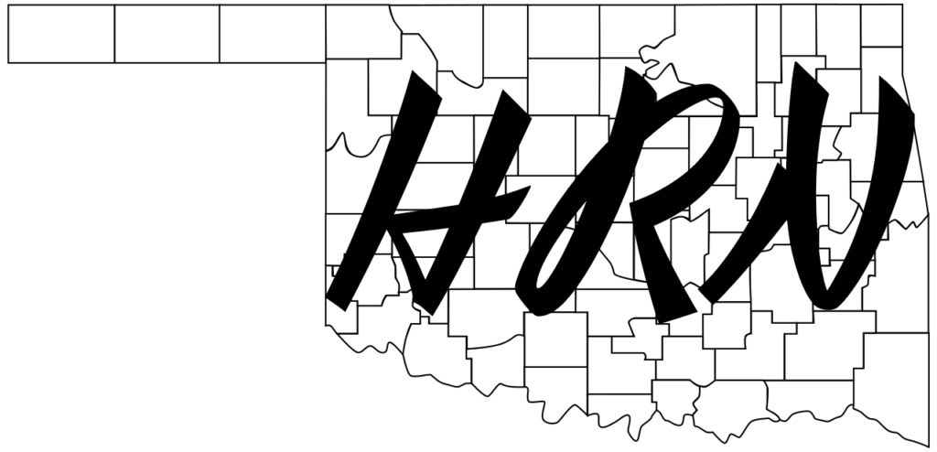
The Hospital Radio Network

Licensed amateur radio operators available to help with your emergency communication needs
- Tornado and disaster response (natural and manmade)
- Communication outages
- Evacuations
- Emergency management preparedness drills

Benefits to you:
- Keeps hospital employees available to do other things during an emergency
- Communicate with satellite clinics, other hospitals, community partners, incident command, etc.
- Helps to fulfill certain Joint Commission requirements* for emergency communications

Additionally:
- All amateur radio operators will be able to bring their own equipment as needed.
- Volunteers can assist you in building and developing your own radio room!
- We can schedule FREE classes to help your employees get their amateur radio licenses (license fees not included).

